**Assignment No. 3**

**1)Write 64-bit ALP to “Hello World” in NASM**

section .data

m1 db “HELLO WORLD”,10d,13d

l1 equ $-m1

section .text

global _start

_start:

mov rax,1 ; “1” is function no. for sys_write

mov rdi,1 ; “1” is file descriptor for standard output device

mov rsi,m1 ;address of m1

mov rdx,l1 ; no. of bytes to be displayed

syscall ; call the kernel

mov rax,60 ; “60” is function no. for sys_exit

mov rdi,0 ; return 0

syscall ;call the kernel

**COMPILATION: nasm -f elf64 a1.asm ===(a1 is File name ,asm means Assembly File)**

**LINKING : ld -o a1 a1.o**

**EXECUTION : ./a1**

**OUTPUT:**

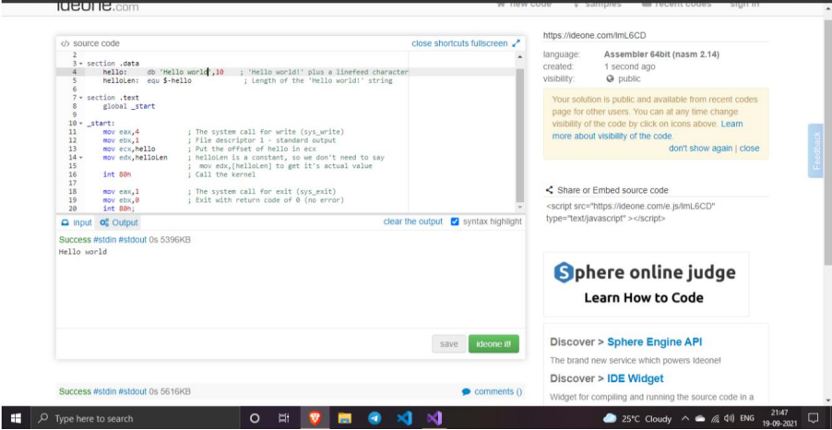

**Name**: Yashraj Vijay Aware

**Division**: D1

**Roll No**:224006

**Prn No**: 22110167